**Supermarket Sales Report**

**1. Executive Summary**

* **📌This report presents the final analysis of supermarket sales.**
* **✅Key findings: The analysis of total revenue by city shows that Naypyitaw is the most profitable city with a total revenue of $100,038.35.**
* **📊 Trends and recommendations: The analysis results suggest that marketing improvements or discounts can help attract more customers, increase product sales, and boost overall profit.**

**2. Introduction**

* **Objective: The main goal of this analysis is to evaluate supermarket sales performance. If sales are low, we explore solutions such as discounts or introducing new products to attract more customers.**
* **Dataset Description: The data comes from a real supermarket and covers the year 2019.**
  + **Key metrics: Total Revenue, Customer Type, City, and Branch.**
* **Business Questions:**
  + **What is the most profitable city?**
  + **Which customer type generates the highest revenue?**
  + **How can sales performance be improved?**

**3. Data Preparation & Methodology**

* **Data Source: Real supermarket data.**
* **Data Cleaning & Transformation: No cleaning was needed as the dataset was already clean.**
* **Analysis Method: Various charts and visualizations were created to display results clearly.**

**4. Data Visualization & Insights**

* **Dashboard Overview: *(Include screenshots of report):***

**1.**

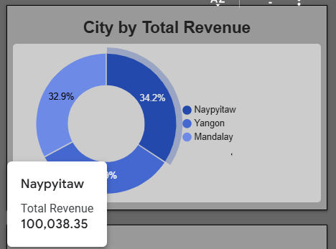

**2.**

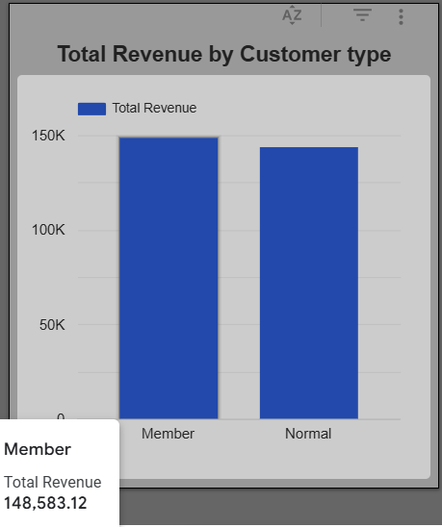

* **Trends & Key Findings:**
  + **Sales Performance: Sales and profit are at a moderate level, with a total profit of $292,208.**
  + **Customer Ratings: Customer satisfaction is generally high.**
  + **Top Region for Sales: Naypyitaw has the highest total profit of $100,038.35.**

**5. Business Impact & Recommendations**

* **Decision-Making Impact: Insights help stakeholders make data-driven decisions to improve sales performance and customer satisfaction.**
* **Suggested Actions:**
  + **Introduce discounts to attract more customers.**
  + **Improve marketing strategies to boost sales.**

**6. Conclusion**

* **Next Steps:**
  + **Conduct weekly sales analysis to measure the impact of new strategies.**
  + **Continue improving customer satisfaction to increase profitability.**